Valve Phonograph Preamp Project – The Groovewatt

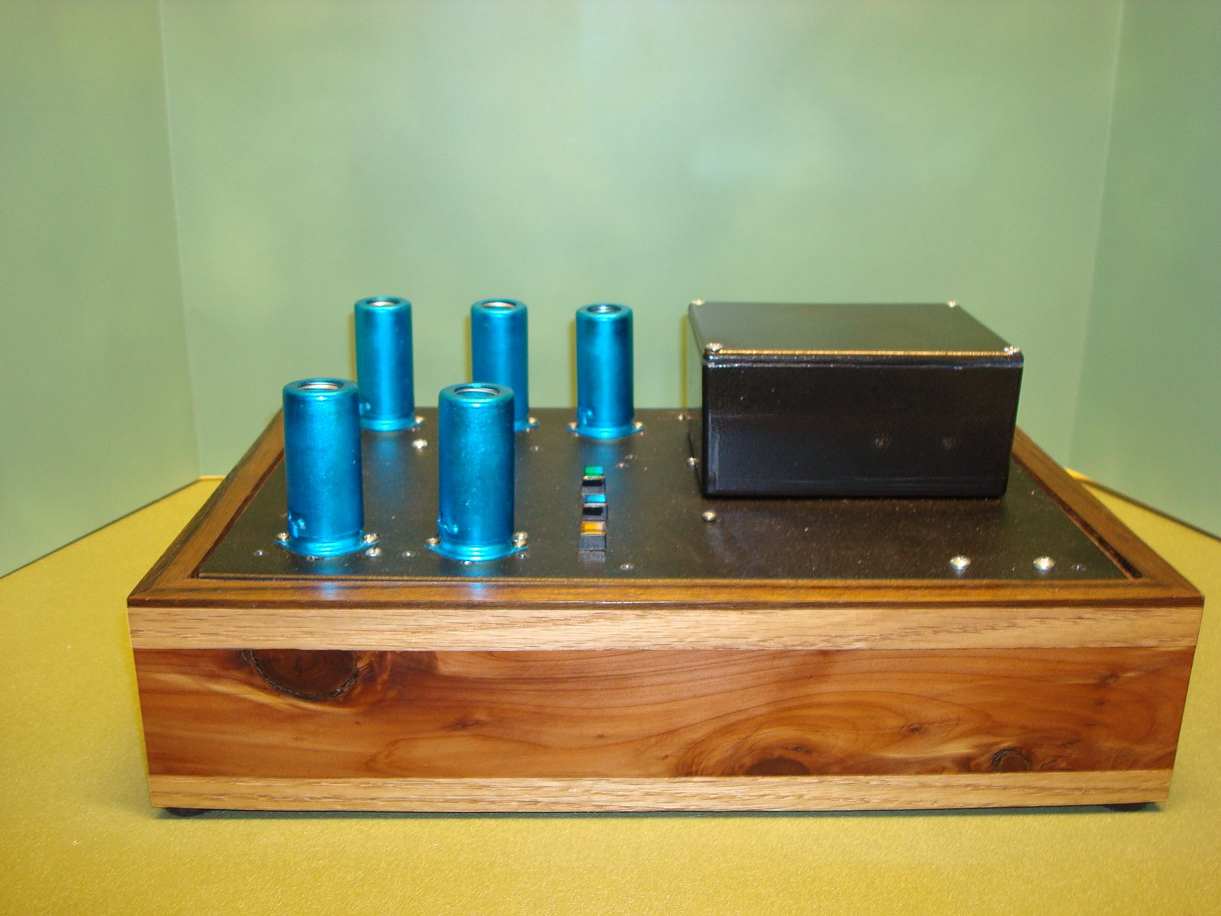
Groovewatt Front View

CAUTION: This project uses dangerous and potentially lethal voltage levels. If you are unfamiliar or do not feel comfortable working with the voltages involved, I highly recommend that you do not attempt the project.

OVERVIEW:

This is a project that I always wanted to do, but managed to put off for a long time. Partly because there are so many good phono preamps in existence and I was slightly concerned that it was beyond my design skills. It took over a year to get it up to my satisfaction. There were several iterations and lots of frustration along the way. My goal was to make a preamp that would not embarrass the builder with inferior performance. I used a number of commercial products for comparison. My thought was why bother to design and build something that was already available for a lower cost. As it turns out, it was not as inexpensive nor un-complicated as I first hoped. I wanted response within 0.5 dbv of the RIAA curve, low distortion, and a signal to noise of about -90dbv. The first two were easy, the signal to noise was not. I did a lot of research on the RIAA curve and the various problems that are inherent in phono preamps. I tried active, passive and a combination of active and passive equalizations. All work and all have positive features and all have negative features. I tried several configurations and tube types. The final design uses things I am familiar with. The input stage is a symmetrical SRPP. It feeds the passive equalization network. The second stage is nearly identical with the first and is direct coupled to the third stage which is a cathode follower. I used 12AX7s in both of the SRPP stages and half of a 6N1P for the cathode follower. Gain is sufficient for me to use a high output MC cartridge (I use a Dynavector 10X5 with an alternate of a Denon DL110) to drive a passive volume control to feed a pair of Oddblocks. The initial design tried using other tubes but none had sufficient gain in the SRPP configuration. The third stage is almost optional as the output impedance of the SRPP is low enough to drive most line stage preamps and directly to power amps with a 100K passive volume control. I added that stage so that it would be possible to drive long cables and following equipment that had low impedance inputs. It is actually possible to drive some high sensitivity 300 ohm headphones to sufficient volume. The preamp is designed for moving magnet (MM) and high output moving coil (MC) cartridges with a signal level over 2.0mv. I believe the best way to handle the output from a low output MC cartridge is with a transformer so no attempt was made to handle them with this project. Please excuse the extra holes in the chassis and the general appearance that the project has seen better days. The chassis is the original one from a year ago and has been reworked so many times it ought to have zippers. Ugly as it may appear, it does work. The name of the project came from another diyer ( ). I asked for suggestions and his was the best. He won an “Oddwatt T shirt” for the idea.

DESIGN CONSIDERATIONS:

The actual design is almost modular in that both gain stages are nearly identical. Circuit values in the equalization section are the exact ones needed and in the case of the resistors you will probably need to series a few smaller ones to get the needed values. Some deviation is possible and while it will alter the RIAA response, the actual amount of deviation will most likely be inaudible. A 110K in place of the 113 K and a 10 K in place of the 10.9K will not mess stuff up much. The capacitors should have tolerances as close as you can get. I used a capacitor meter to select mine from a large batch of samples. With both the resistors and capacitors, the closer to the values the better the performance will be.

I used all audio grade (in this case Jantzen) capacitors as bypass capacitors and only quality electolytics. The output capacitor should be a “poly” for best results. The one I used was a WIMA MKS. For the inter stage coupling capacitor I used an Auricap however other quality brands ought to be satisfactory. In both instances the capacitor will tend to “flavor” the overall sound. If you know how they sound and like some other brand, by all means use them.

I wanted to have the capability to do mono records as well as stereo. So I included a switch that connects the two channels at the input. It also activates a pair of indicator LEDs (visible on the chassis top) so that I would easily know what mode it was in.

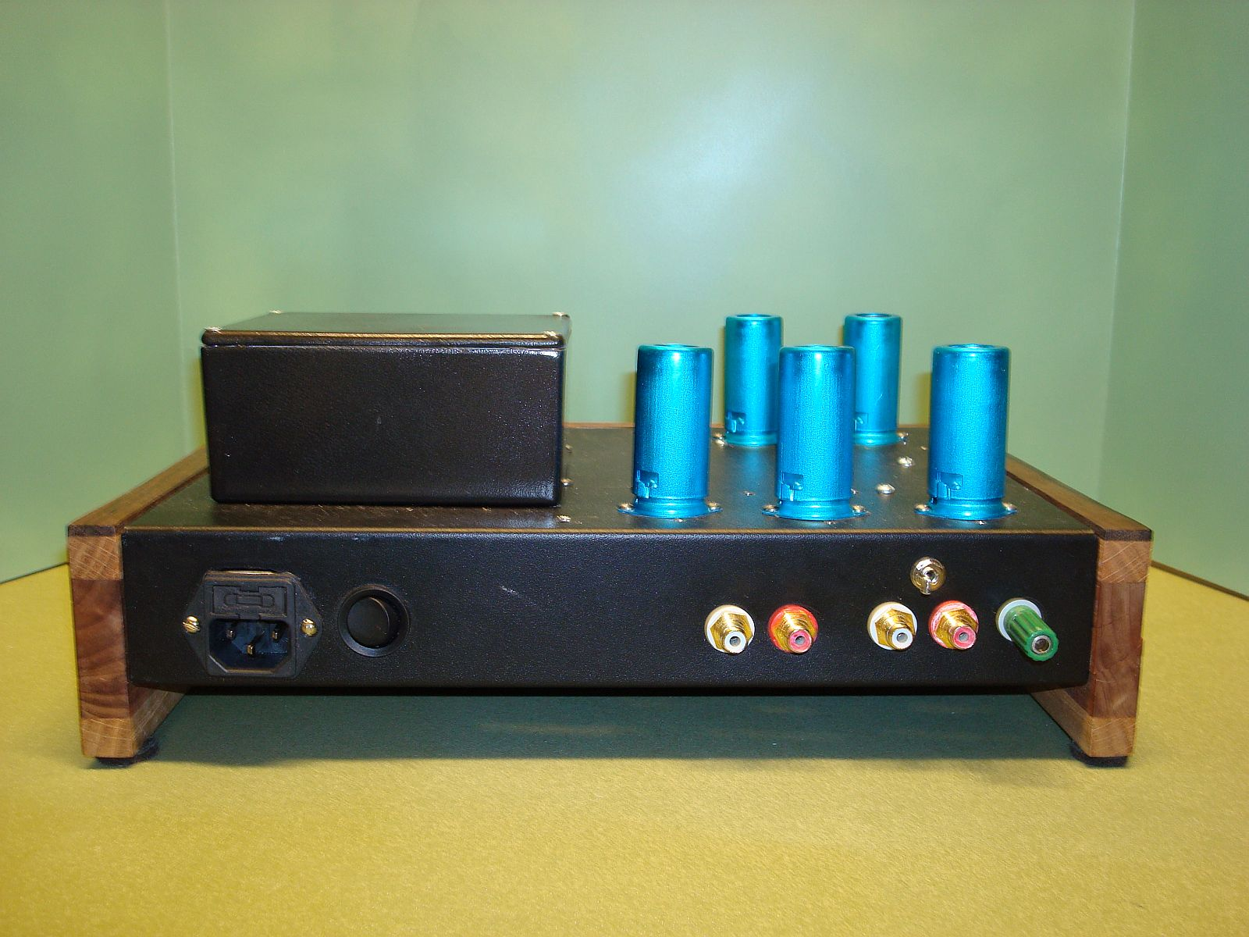
Groovewatt Rear View

POWER SUPPLY: GENERAL

The power supply is fairly straight forward in design. It uses an inexpensive transformer from Edcor. A toroid would be fine, but I could not find one that was inexpensive and suitably small. One I did find was nearly three pounds and about 5 inches in diameter. The high voltage is rectified by discrete solid state rectifiers. The specified ones (UF4007) are a fast recovery variety and standard rectifiers should not be used. The filter section is divided into two separate strings, one for each channel. This is done to enhance channel separation. Electrolytic filter caps are bypassed by audio grade polys. In one version I used LR8N solid state regulators in the high voltage string. They work fine, but the additional filtering they provided did not seem to improve the overall S/N greatly and the complication I felt was unjustified.

HEATER SUPPLY:

I employed dc on the heaters. The 8.5 volt winding on the transformer was rectified by a full wave bridge and filtered. Then it is routed through a single solid state rectifier (to drop the dc voltage by approximately 0.7 volts) to a second filter and then applied to the tube heaters. The circuit MUST not be grounded. I apply a positive voltage to the heater circuit of approximately 80 volts to protect the SRPP tubes from excessive cathode to heater potentials. They will fail if you don’t do this. The positive voltage is obtained from a divider string originating from the B+. Two stages of filtering were necessary to reduce the noise level to satisfactory levels. Do not omit the poly caps in the divider string and it is unnecessary to use larger values. There is virtually no current drawn by the divider string (over the small amount used by the dividers themselves) and there is no return path from the heater circuit. The voltage only provides a reference for the heaters.

CONSTRUCTION:

This is a high gain circuit and needs to be treated as such. Open loop gain is in the 60dbv range and thus it is quite sensitive to picking up noise and hum. Layout is important. The signal path from input jack to the first SRPP should be short. If more than about 1-2 inches it needs to be shielded. The components in the passive equalization section need to be shielded as well. I suggest that the chassis be partitioned off into sections. Power and signal wires and components should be separated when possible and cross at right angles when they can’t be separated. The power transformer could be problematic as it is unshielded. If you place it on top of the chassis it will radiate into the anodes of the tubes. On top of the chassis it must be encased in a metal enclosure and the tubes need shields. The use of tube shields is recommended in any case as the tubes can pick up ambient noise. I put the transformer inside the chassis inside a cast metal box like is used for electrical connections. The boxes have mounting flanges and are easy to mount inside the chassis. The transformer itself just fit between some slots in the box but could be mounted on a small perforated PC board with standoffs between it and the box. It has pins spaced for normal PCB mounting. The filters and associated parts were mounted in a similar box on top of the chassis with holes bored through to the transformer section. The filters could have been placed inside the chassis as well, but in this case I didn’t have enough room. Plus the box nicely offset the tubes on the top of the chassis. The boxes and chassis are electrically in contact to both preserve the safety against faults and to form an effective shield. I always use three wire IEC connectors and a combination AC input/line filter and integral fuse assembly. You can choose to have a power switch or not. That would depend on your system. If you choose not to have one, a B+ standby switch would be in order. Mine has a mains switch.

START UP and VERIFICATION of ASSEMBLY:

First look for loose wires and components. Turn the chassis upside down and shake it. You might be surprised how much junk falls out. Insert the fuse and tubes. Do not connect to any stereo gear (just in case there is a catastrophic fault). Connect the power cord to the preamp and turn the switch on. Do not connect the cord to the AC mains until later. This insures that you will not become part of the circuit in the event there is a short to the chassis. Attach a voltmeter to pin 6 on the first stage SRPP. This is the mid point and is the best indication of proper initial operation. Set the range (if not an auto sense meter) to 300-500 volts. Plug the power cord into the AC socket. Watch the meter reading.
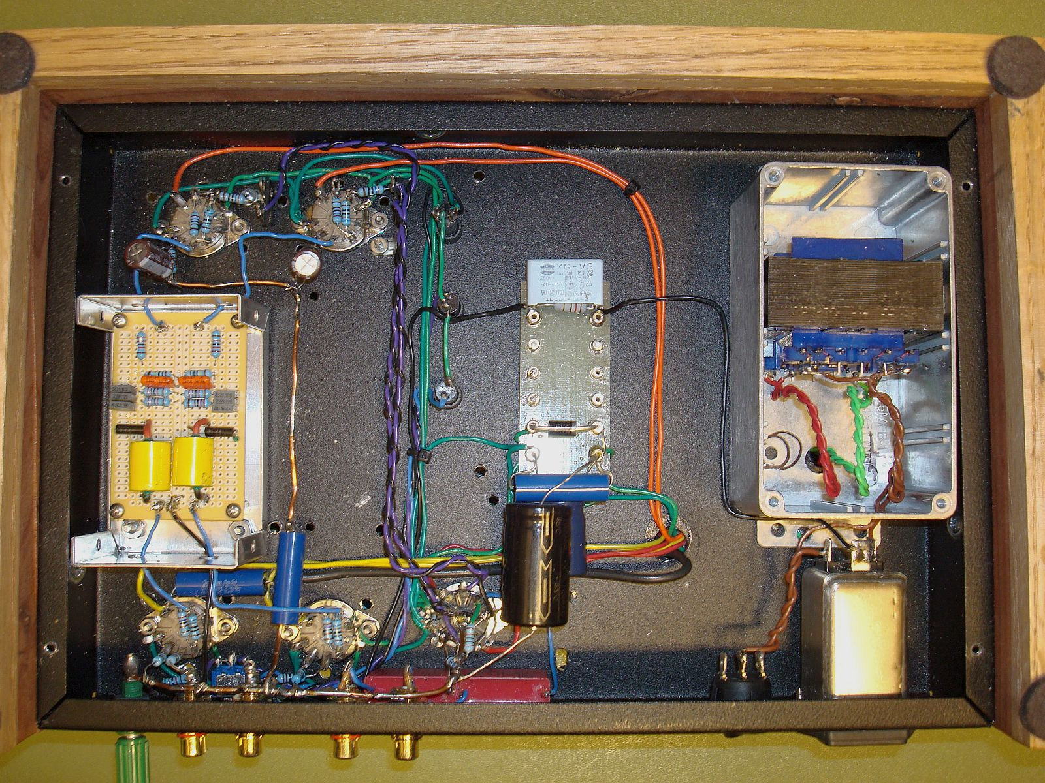
Groovewatt Inside With Covers Removed

It should be in the range of 80-120 volts after about 30 seconds. If it remains zero or is greatly outside that range, remove the power cord from the socket and look for some sort of wiring error. If it is in the proper range move the “hot” probe to teach of the SRPP tubes (pin 6) in turn all should be in that general voltage range. The variation is because of gain differences between the two triodes in the tubes. Then check pin 8 and pin 3 on the 6N1P. The reading should be also in the same range. If any readings are way off, or there is arcing, sparks, etc, disconnect the power cord and look for errors. Next check the voltage on the heater circuit. Between pins 4 or 5 and 9 on the 12AX7s it should be close to 6 volts DC. A little (up to about .25 volts) above or below is fine. Then measure the DC voltage from pin 9 on any of the tubes to the B+ ground. It should be between 70 and 90 volts. Any time any of the readings is greatly different you should stop and determine the cause. If all readings fall into the proper ranges you can now try the preamp in your system. If there is excessive hum, noise or no sound, then you need to go back and find the error.

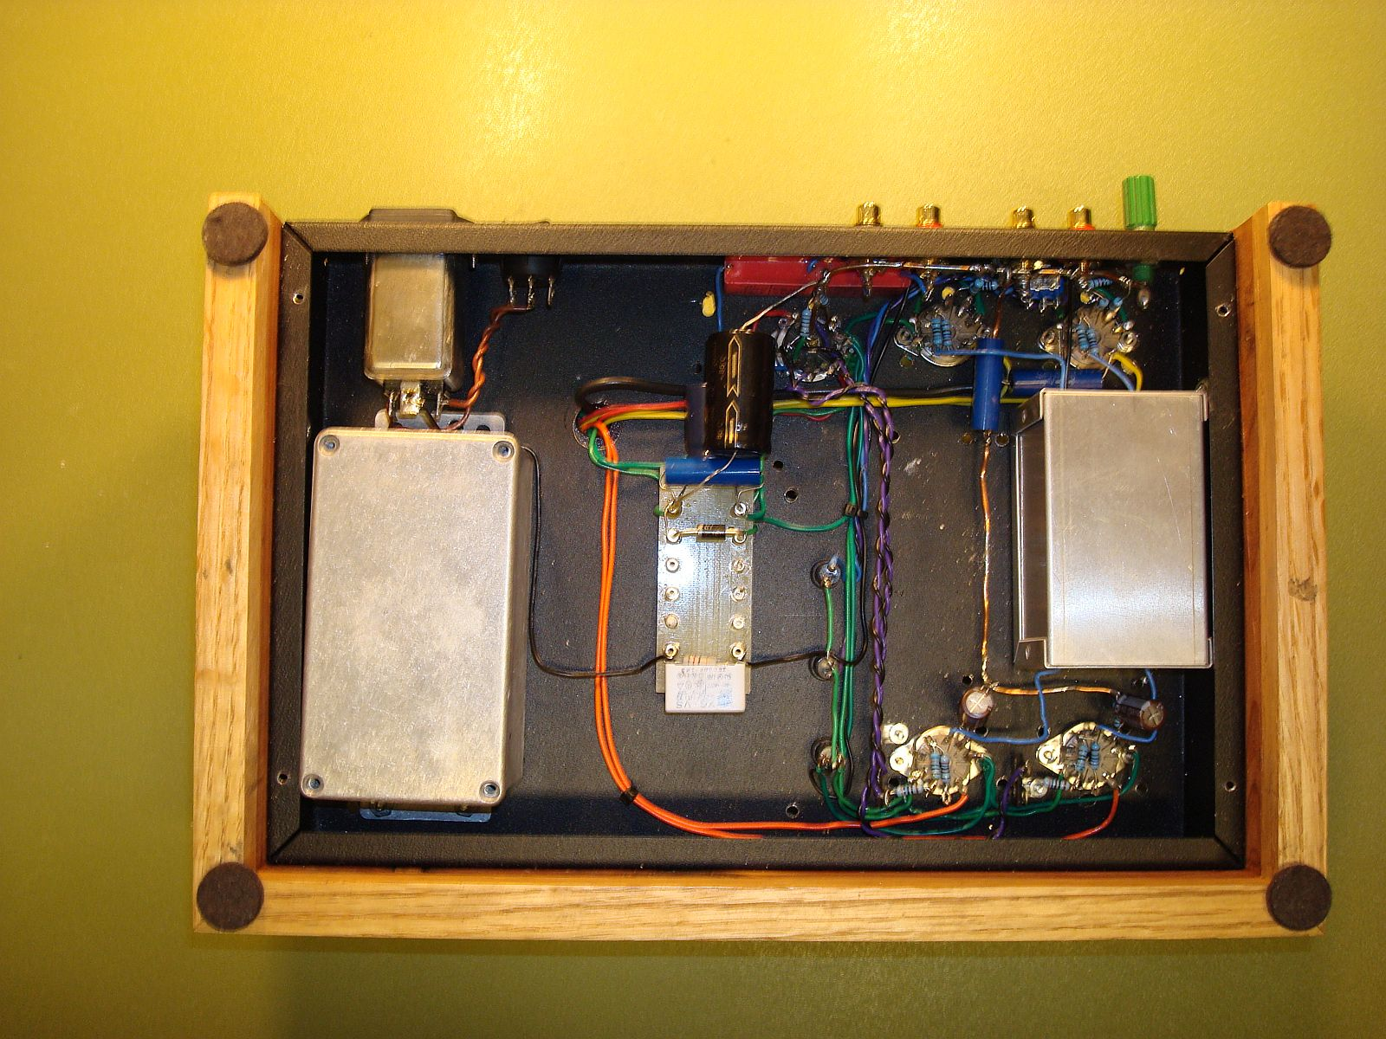
Groovewatt Inside With Covers In Place

LISTENING:

As always your results may be different from mine and what and how you listen is likely to be different as well. My main system consists of a pair of Martin Logan Vistas (ESLs) driven by a pair of Oddblocks using JJ Blue Glass EL34s, A pair of 7 cubic foot subwoofers with 15 inch drivers powered by an Amp 100 (so I use a piece of SS gear- for this application it works), signal separation is handled by a Marchand 24 db/octave electronic crossover set for 50HZ, a Forewatt line stage preamp (usually set in passive mode), an OPPO 83SE for a digital source, a Pro-ject Debut III with speedbox and acrylic platter with a Dynavector 10X5 MC cartridge and for a back up phono preamp a Simaudio Moon LP3. With the GrooveWatt in place, the sound is exceptionally smooth, but not lacking in details. It is full range with solid well defined bass. Soundstage is approximately as wide as the Moon LP3. At any reasonable level there is no background hum or noise. The music flows smoothly from a completely dark background. It is quieter than any LP I own. The Moon is quieter, but then it is among the quietest phono preamps available (at about -105 dbv).

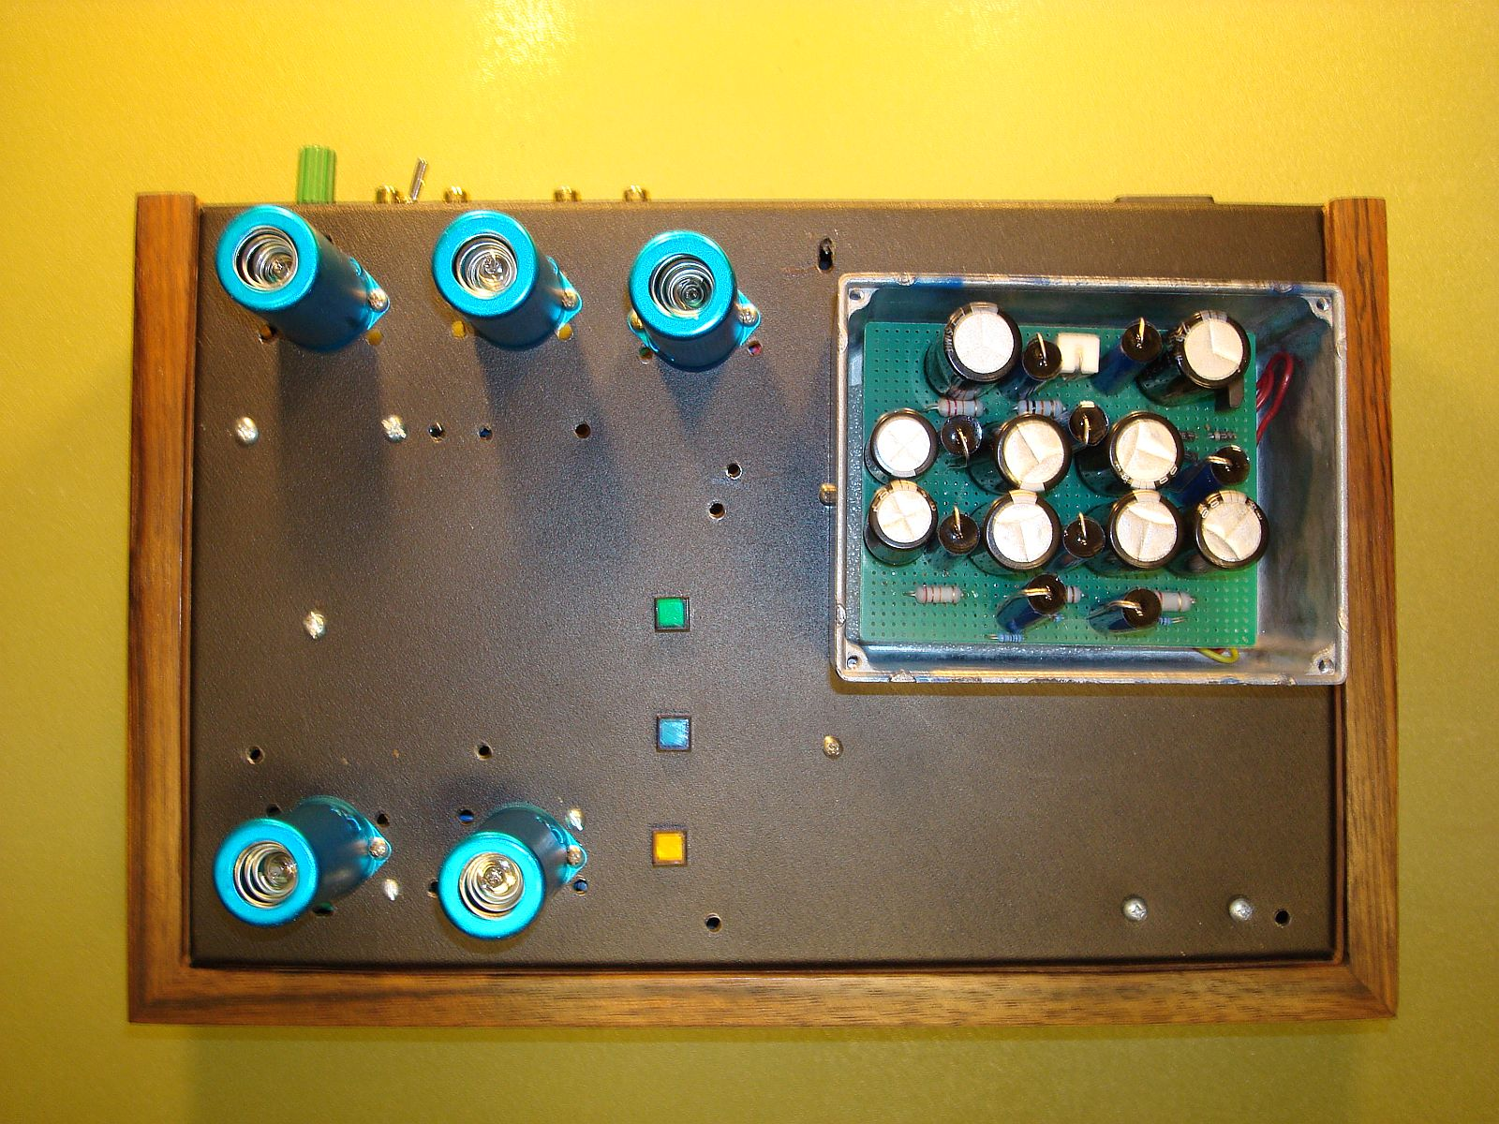
Groovewatt Top View With Filter Cover Removed

FINALLY:

As with all DIY projects, it is as much a process as an end result and I fully expect to make some refinements to it. So stay tuned to the Forums where the changes (if any) will show up first. This is not a simple project, but equally it is not at the expert level. I hope it will give you as much pleasure building and listening as it does for me.

Good Listening
Bruce

