SOLID STATE IC BASED PREAMPLIFIER FOR MOVING MAGNET (MM) AND LOW OUTPUT MOVING COIL (LOMC) PHONOGRAPH CARTRIDGES

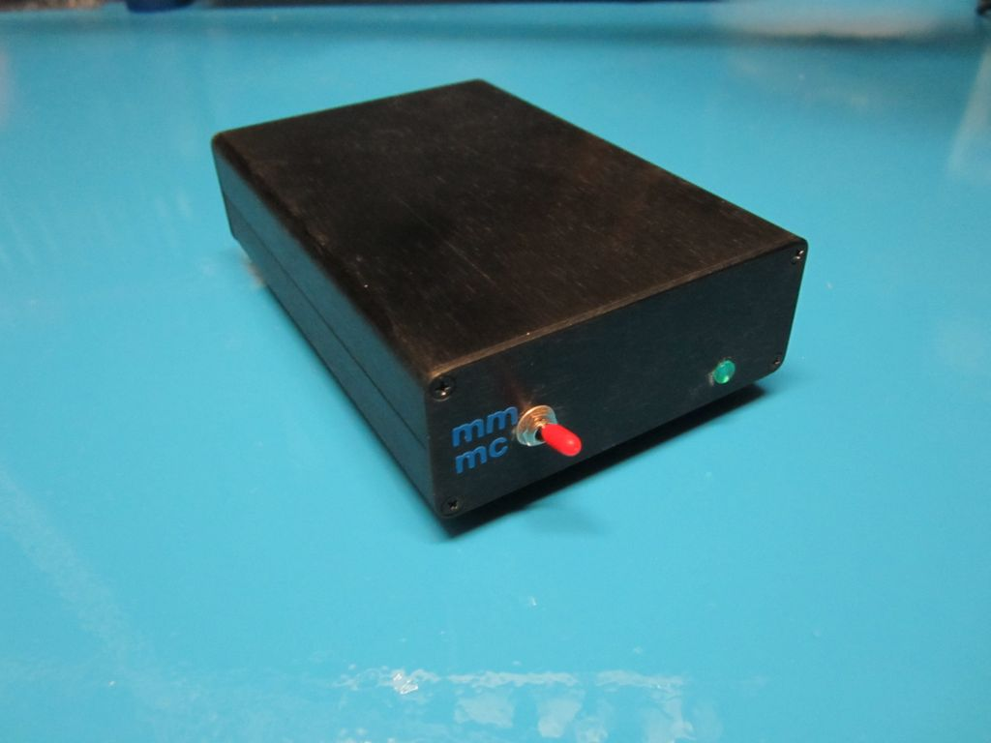

GENERAL
This project is a departure from my normal sort. It is solid state… yup I transgressed to the dark side. Actually I have nothing against solid state and use a number of solid state components in my designs. The project is for a relatively simple high performance phonograph preamplifier that can handle both moving magnet (MM) and low output moving coil (LOMC) cartridges. The basis for the project was a temporary need to have a LOMC preamp in addition to the valve ones I have to study low noise performance. Without trying to start any arguments, I have found that it is a lot easier to make a low noise high gain solid state circuit than it is to do the same for a valve one of similar capabilities. The circuit I came up with is pretty much like many common IC based phonograph circuits. I did go through the process of doing the calculations and then some final tweaking with both my test equipment and use in my reference system. The values were initially fairly close, but tweaking made the performance significantly better. I used quality components throughout. I have always sought ways to do things better and easier so the power supply is a great example of this concept. I won’t say I cheated, but I did use a solid state DC to DC converter to get the symmetrical voltages needed (available from Jameco for $10.95 each). For those of you unfamiliar with the Meanwell converter it is about the size of an ice cube and takes anything from about 9 volts to 18 volts DC as input and puts out symmetrical regulated plus and negative 12 volts DC. This particular one is limited in current to about 125 ma on each rail. Other members of the family can deliver more and there are numerous voltage combinations available. Another one I like can take 120 or 240 volts AC input and deliver a regulated 12 volts DC at nearly half an amp. It is not much bigger. Line to load isolation is excellent. Since the output from the converter is regulated and symmetrical around “zero” volts there is no provision for restricting DC gain or offset. None was needed as constructed. Offset adjustment might be necessary if you use a different method of power the circuit.

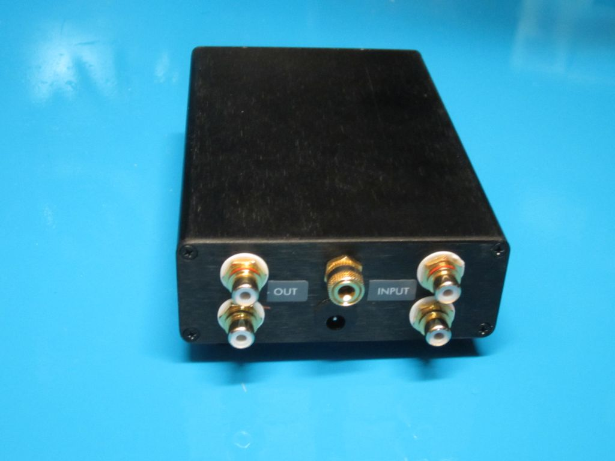
Rear View

DESIGN CONSIDERATIONS
The circuit is a non-inverting IC based filter with significant gain. Four of the components in the feed back loop determine the proper RIAA compensation. Slight variation in any of them is unlikely to be audible. The remaining components determine the gain and are for stability. Using a 330 ohm resistor from the inverting input to ground will result in sufficient gain for MM cartridges (about 43 db). Putting a 51 ohm in parallel with that resistor will increase the gain sufficiently to permit the use of LOMC (about 61 db). Calculated values were different from these values and the gain was determined by measuring it. The values are approximate as they input signal levels are approaching the noise floor of my test gear. I used a 4 pole double throw mini switch to change both the gain and input loading resistors to match my cartridges. Compliance with the RIAA curve was excellent. When I measured it, I was limited to the tolerance of the components (hand selected to be under 1%) in my reverse RIAA filter. The values on a Bode plot (done with a PC based DSO) of the response were within 0.2 dbv from 20 HZ to past 30 KHZ (yes I know the RIAA standard doesn’t go that high, but I can test for that response). Signal to noise was better than -90 dbv for either type of gain at any frequency. Throughout the majority of the audio band it was very close to -100 dbv. The input loading resistors should be changed to match your needs. I suggest using dip switches and having several values available. This is particularly the case for LOMC cartridges. Suggested values would be from about 40 ohms to 500 ohms. Since the resistors are shorted to ground it is possible to get several combinations in parallel as well as individual values. For MM cartridges the normal value is 47K ohms. This can vary with some cartridges and you should use whatever value works best for your cartridge. No input capacitance was used, but it is sometimes needed with MM cartridges. Values in the range of 100 to 220 pf are typical. The need for them depends on the cartridge and the cabling between it and the preamp. Often the cable will have sufficient capacitance to negate the need for additional capacitance at the preamp input. I didn’t measure distortion as the results were likely to be inconsistent because of the measuring method needed. However since this is a high gain feed back controlled IC amplifier I would expect the values to be very low.

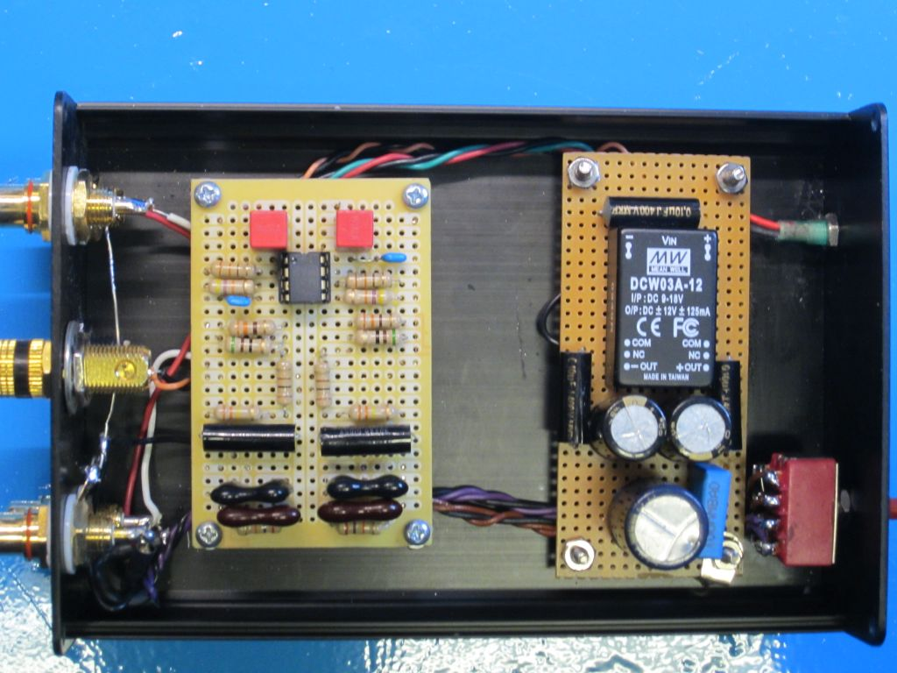
Inside the Preamplifier (the ground buss wire does not touch the ground terminal)

THE BUILD
Actual construction is not difficult. There are some things that do however matter. Grounding is always important in high gain circuits. I use a modified “star” system. The power supply and active circuitry each have their own “star” the center point of which are connected to a “buss” ground wire that runs between the input and output jacks. I use silver wire for the “buss” as it has very low resistance. It is also important to keep the ground connections as short as is reasonable. The power supply components should be kept away from the inputs and main circuit if possible. Even though the converter operates outside the audio band it is possible to have it interfere with the active circuitry. About 2 inches of separation is sufficient. The final 0.1uf capacitors should be as close to the IC as possible. I used common perforated boards. Pretty much any form of construction is going to be OK. I use sockets on my ICs. It makes it a lot easier to replace an IC if something goes wrong and you cook it. It is also easy to try different ICs. BTW there are many ICs that share the same pin connections and can be substituted for the Burr Brown OPA2134. It is a dual operational amplifier, but there is no reason singles could not be used. The only restrictions would be that they be low noise, low distortion and high gain-bandwidth product ones. Most recent audio grade ICs meet those requirements easily.

OTHER CONSIDERATIONS
The circuit can be powered by nearly any wall wart if you use the specified DC to DC converter. Cleaner DC is preferred but doesn’t seem to be all the necessary. You can of course use a pair of 9 volt batteries to power it as well. Alternative more conventional power supplies can also be used, but the signal to noise will depend on how quiet they are. Bear in mind the earlier comment regarding DC off set and different power configurations. A fully shielded metal enclosure is essential. The preamplifier will pick up noise and hum quite easily if it is not well shielded. Do not ground the input or output jacks to the case. The 150R and 0.1uf type X2 capacitor are the only things that should be connected to the case. A ground terminal is affixed to the case for connection to the turntable ground. Any other connections can result in a ground loop and seriously degrade the signal to noise performance.

LISTENING
This is where things always get fuzzy. What I hear and what my system does is quite unlikely to be the same as your results. That said though, this is a surprisingly nice sounding preamplifier. My reference system consists of a digital remote control preamplifier that I designed. It was used in the passive mode. It uses a relay switched digital array of precision metal film resistors to adjust the output. It feeds my reference pair of KT88 Oddblocks (numerous upgrades like Russian Teflon capacitors). The speakers are Martin Logan Vista ESLs that are augmented in the sub 40 HZ range by a pair of Martin Logan powered subwoofers. I used an AT33PTG/II cartridge for the LOMC in an Origin Live tonearm on my custom turntable (made from a Dual 701 direct drive). I used a Grado Reference Platinum I in another Origin Live tonearm on a Sota Moonbeam for the MM testing. The AT cartridge is an exceptional performer. Anyone needing a LOMC should seriously consider it. Unfortunately at approximately $500US, it is not cheap and is available only directly from Asian sources. The sound through the preamplifier was clean, detailed and had a wide sound stage. It was at least as quiet as my reference valve preamplifiers that use step up transformers. The bass response was solid with a clean mid range and top end. I have heard fairly costly solid state preamplifiers that were not nearly as satisfying. It was quite listenable and had rather nice presentation. With the Grado, the response was typical of the cartridge. It had really solid bass, very warm midrange and clean highs. The Grado and preamplifier would be a terrific rock combination if the rest of the system can keep up with them. I briefly tried an Ortofon OM30 and it sounded just fine as well.

FINAL THOUGHTS
This is an easy to build project that will not cost a fortune. The ratio of “bang for the buck” is quite high. I estimate a frugal diyer could duplicate the preamplifier for about $100. The biggest cost variation will be the case. Mine was $17. I used quality components and they can add to the cost, but really premium ones don’t seem to be justified. BTW, I have no intention to give up my valve preamps for a solid state one. The quality of presentation provided by the valve preamplifiers is significantly different from the solid state ones I have heard and at least to me, much more to my liking.

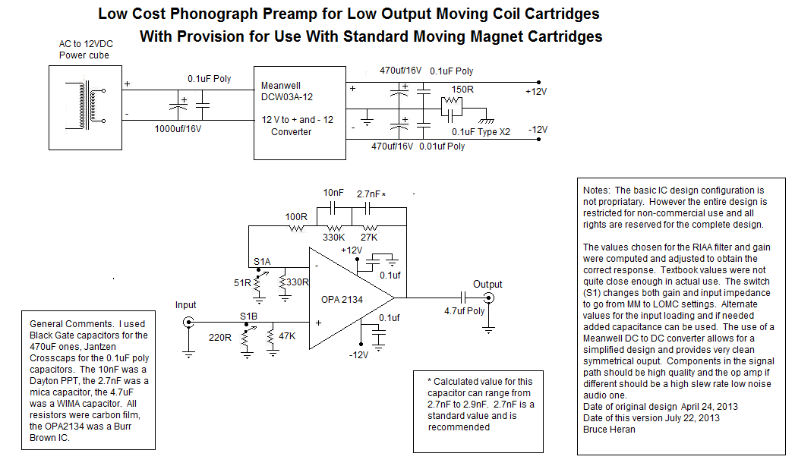

Good Listening
Bruce

