COBIES (Cheap Open Baffle Speakers)

This project was inspired by the “Big Air” open baffle system by Jim Strasser (please contact me for additional information regarding that system). That system is a simple good sounding system based on a different woofer, smaller baffle and does not incorporate a few other things I added. My target cost was to build a pair for under $150. In exploring the possibilities of open baffle speaker systems I reviewed numerous sources to gain an understanding of how they function. I additionally used a program xbaffle.xls (available on the WEB written by Thorsten Loesch and permitted only for non-commercial use) and LDC7 (from the Loudspeaker Design Cookbook by Vance Dickason) to test various aspects of the speaker system before actually constructing it or making changes. I ended up with a larger baffle, a different woofer, a symmetrical crossover, and the inclusion of a rear firing tweeter. Clearly not as simple as the original system but I felt the changes worth the effort. I normally listen to Martin Logan Electrostatics and I have come to like the sound field they present. To date I have not found any “box” speaker systems that can equal the electrostatics’ ambience. Thus was at least part of my desire to explore the open baffle concept.

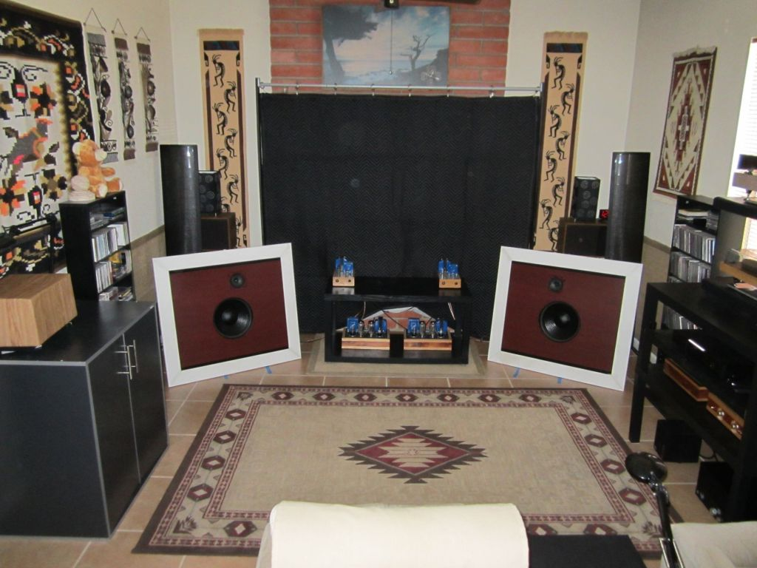

Open Baffle Speakers in My Listening Room: Note that the white frame work on the baffles was done during the design phase to enlarge the baffles from the smaller original size to the desired larger size. It is recommended from a structural standpoint to use a single piece of plywood the correct size. Also note that the final physical placement should have a slightly greater “toe in” angle.
GENERAL COMMENTS:
This speaker system was planned as a “budget” system that would have a high level of performance. The desired total cost was to be under $150 for a pair of speakers. This would include a 4X 8 sheet of ¾ inch plywood. I wanted to use only easy to obtain and cost effective electrical components. As it turned out all parts are available from Parts Express and are just under $94 (plus shipping) for a pair of speaker systems. The cost of the plywood and assorted fasteners and things like glue would depend on your local suppliers. The system that inspired the quest (the “Big Air”) used a 12 inch woofer made by Zenith about 30 years ago. It is readily available on the web (specifics available if requested) for about $50 a pair in good condition. These woofers have a rather nice mid range and blended well with the GT25 tweeters with only a single capacitor to block the bass frequencies from reaching the tweeter. The baffle was a bit smaller at roughly 25 inches by 29. Using those dimensions and the original speakers I found the response (at least in my room) to be quite pleasant in general and with an overall decent presentation. They did however fall off rapidly below 80 HZ and they had a significant bump in the 100-120 HZ range. To my way of thinking (listening) this was not acceptable. At this point I started to do some research and experimenting. Initially I tried to correct the response anomalies by various means, none of which were really satisfactory.

The first major change was to do a bit of modeling with the xbaffle spread sheet to see if any inexpensive woofers existed that might perform well in an open baffle design. High efficiency, low F3 and high QTS were clearly advantageous in the model. A clean mid band and extended top end were also desirable. Of all the speakers modeled the one that matched best was among the least expensive carried by Parts Express (#292-412, GRS-12PF-8, 12 inch woofer, $15.88 each). I ordered a pair and to my surprise they are rather well made. Amazing what you can get for $16. The GRS woofers made a major improvement in the bass region, but did not seem to blend as well in the upper mid range with just a capacitor for a crossover. I calculated an inductor to use thus making it a true high and low pass first order crossover. This did wonders for the blending. The modeling indicated that a slightly larger baffle would make the bottom end even better. I enlarged the baffle by 3 inches on all sides to the dimensions given in the attached plans. Again there was a significant improvement. Still the sound was lacking. I expected an open baffle system to have a room filling sound somewhat like the electrostatics I have. As it was it seemed to lack the dimensionality I expected. I went back to the basics and did a bit more reading. A number of other open baffle diyers had the same experience and added a rear firing driver. This really should have occurred to me as the tweeters are a closed back design. I ordered another pair. These I installed on the rear of the baffle just over the exiting ones with an angle of about 45 degrees off the vertical. With the baffles tilted as designed with an approximate 15-20 degree tilt this means the rear tweeters are tilted at nearly a 60 degree angle. Since the tweeters are 8 ohms each and the woofer also 8, I had to add a resistor to the crossover to make all the impedances match at the crossover point. The tweeters are in series as shown in the schematic. Be sure to observe the polarity of the various components as it will have a major effect on the way the system behaves.

The Build
The construction is rather simple and some latitude in it is not likely to have a major impact on the performance. 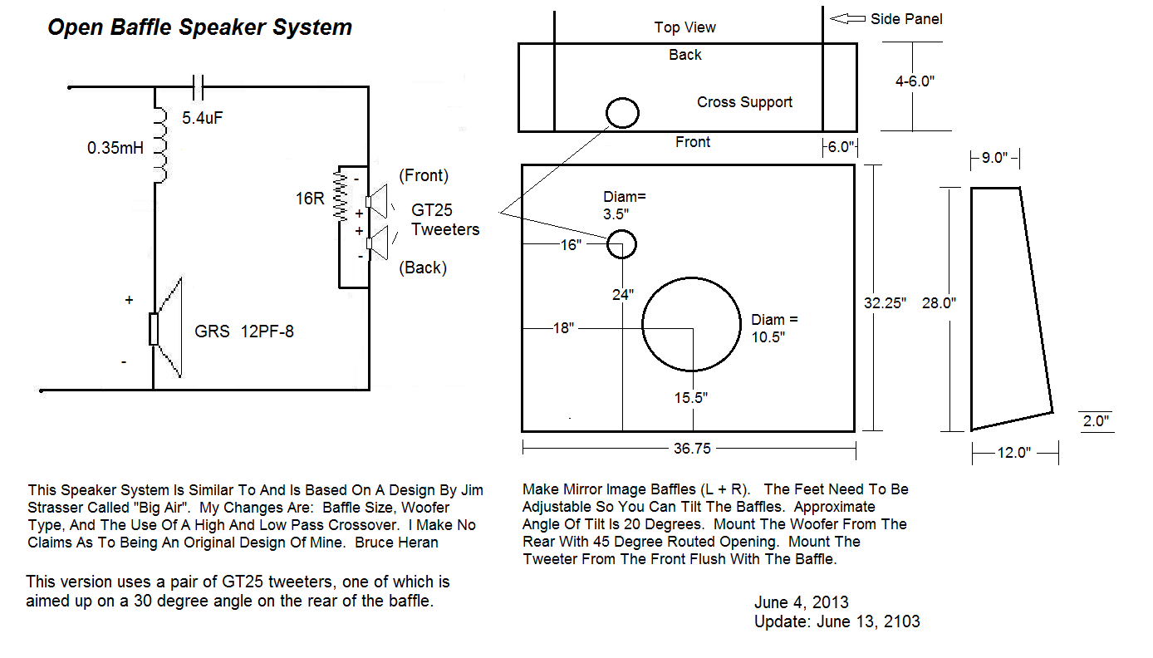
The baffles can be constructed of nearly anything sturdy. Materials that easily resonate should be avoided as it will color the sound. I used ¾ inch plywood. You can have the lumber yard cut the major parts for you. The speaker cutouts should be located as shown on the drawing. The most difficult part will be to router the woofer cut out at a 45 degree angle. This is a feature of the original open baffle design and I carried it over to this one. It might not make a lot of difference if the woofer is front flush mounted as opposed to rear mounted and thus the routing might be easier. The rear of the tweeter cut out does not require any treatment as the tweeter has a closed back. The side panels are not rectangular, but for ease of construction they could be made that way. The actual dimensions of them are not really critical and if the panels were made rectangular then all that would be needed is to fasten them about 2 inches from the bottom edge of the baffle. This would approximate the correct tilt angle. The panels should be at least 9 inches wide at the top though. For rectangular panels I would use a constant 12 inch width. A cross support was included to add rigidity to the side panels. Its width is not important. It should be placed approximately 4 inches below the woofer but the distance is not critical. You can fasten the sides and cross support in pretty much any way you wish. I used hot melt glue and angle brackets. I used two small pieces of wood cut at 45 degree angles to mount the rear facing tweeters. The tweeters were fastened to them with wood screws. You can try aiming them at other angles for different effects. All wiring was point to point and the crossover components were mounted on the bottom of the cross support. You can use any method you choose to do that part. I suggest that you not use wire less than 16 gauge though. This concludes the construction.
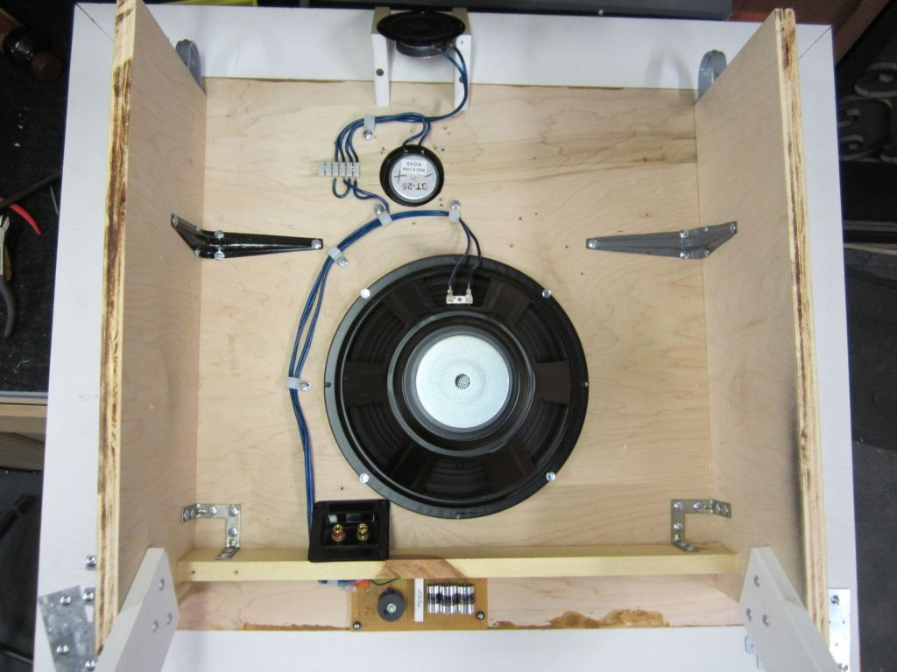
Rear View Showing General Layout (early phase – crossover components, side panel and brackets were changed later)
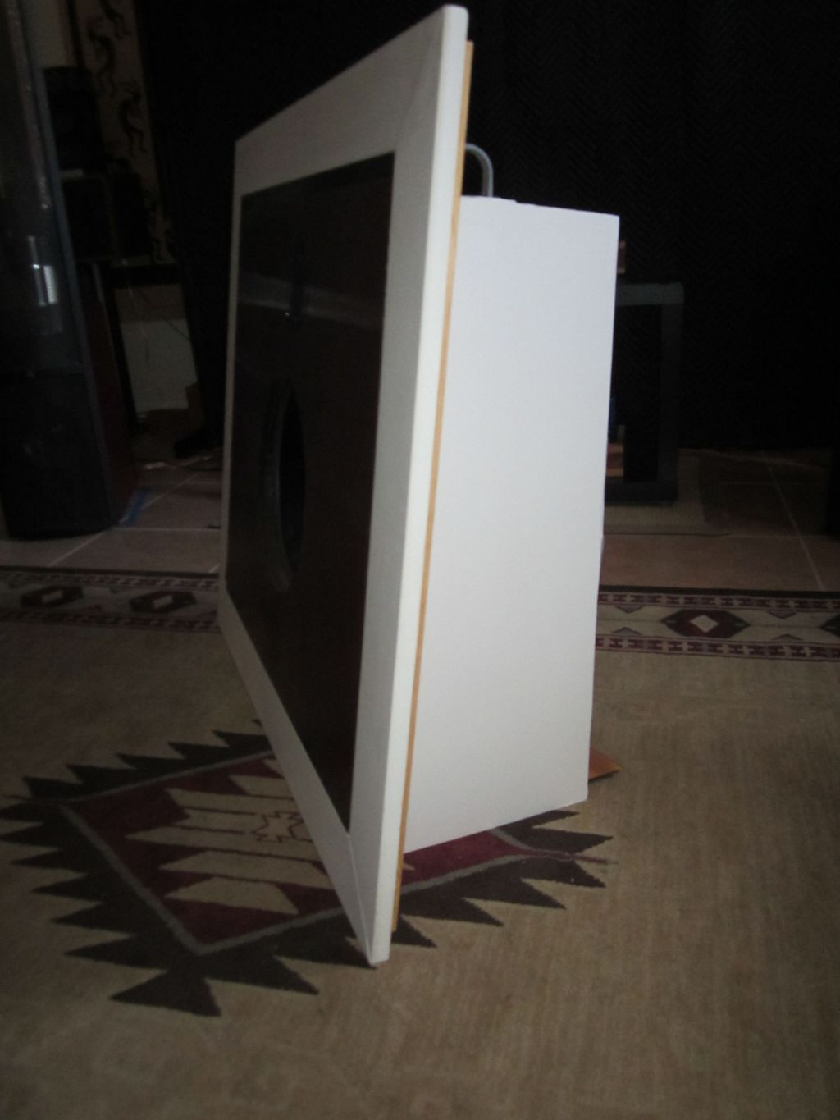
Angle View Showing the Side Panel

Use and Listening Considerations
Open baffle speaker systems offer some unique advantages and have some considerations that can cause consternation. Being a type of bi-polar system there is considerable reflected sound. This is both a plus and can easily be a detractor. Room placement and room treatments weigh heavily into this situation. I found that a relatively dead (sonically) area behind the speakers was helpful in my listening room. The existing wall there is sheet rock over brick and is highly reflective. I used a large “furniture pad” specially designed for the purpose (available on the web for pro audio applications) to tame the reflections. It was needed for the electrostatics to behave properly as well. The side walls and opposite end wall can be fairly reflective and depending on your tastes can be treated to enhance or reduce the reflective sound. The open baffles seemed to work best in my room about 10 inches from the side walls and about 48 inches from the wall behind them. Angling them inward seemed to enhance the ambience and simultaneously improves imaging. You can also swap the left and right speakers for a different effect on how the tweeters behave in the listening room (more centered as shown in the photos or wider apart). The GT25 tweeters are quite adequate, especially considering the cost. They respond well in the range chosen. Various crossover points from 2000 to 6500 HZ were tried before settling on 3600 HZ. Lower crossover points put too much of a demand on the tweeters and resulted in a “hole” in the response just above the crossover point. Crossover points above the one chosen resulted in deficiencies in that region and allowed anomalies due to woofer above band irregular response. The best listening position was slightly closer than that with my electrostatics. It ended up as a nearly equal distance between each baffle and to the listener. Modeling indicated that the speakers would work rather well placed in the room corners at an angle of about 30 degrees. I could not verify this as the fireplace hearth (behind the furniture pad) prohibits that arrangement. Since the speakers are a diy project and how they are placed in your listening room matters, I would certainly try those and other locations if possible.

Using a calibrated microphone and computer program the final response was much as predicted and similar to the electrostatics. The mid band from 100HZ to 10K HZ was quite smooth and free of any large irregularities. Response below 100HZ was affected by room nodes but quite good down to 40HZ. Response above 10K HZ was certainly excellent (up to about 18K), but the measuring set up would not permit accurate results in that region. The speaker efficiency is fairly high at an estimated 93 db / watt at one meter. My 5 watt each tube mono block amplifiers had no problems delivering a louder sound level than is comfortable.

How Do They Sound
The sound is something you will either love or hate. As I said earlier open baffle speaker systems are bi-polar. I really like it, some individuals will not. The speakers have an excellent overall sound. They have a lot of ambiance and provide a good listening experience. Bass is quite clean and robust and the mids and highs are well done. I won’t tell you that I’m going to give up my electrostatics and use these instead. No, but there are many speaker systems out there at far higher costs that don’t provide nearly as good a rendition of music.

Parts List
All electrical components are stock items from Parts Express.

292-412 GRS-12PF-8 12 inch woofer $15.88
270-018 Goldwood GT25 tweeter (two per baffle) $5.77
255-220 Jantzen 0.33mH coil $5.26
027-556 Solen 5.6uf capacitor* $4.23
027-276 Jantzen standard Z 5.6uf capacitor* $4.48
004-(XXX) 10 watt resistor 16 ohms $1.25
NNN-NNN Speaker Terminals $3-8
* Either is suitable my preference is the Jantzen.

4 X 8 Sheet of plywood $25-50

Speaker Specifications
GRS-12PF-8 GT25
Power (wrms) 120 35
Le (mH) 1.15
Z (ohms) 8 8
Re (ohms) 7.56
Range (HZ) 35-5000 3000-20K
Fs (HZ) 35 1500
SPL (db/w) 87 90
VAS (cubic feet) 5.28
QMS 5.97
QES 2.08
QTS 1.54
Xmax (mm) 3.5

Good Listening
Bruce Heran

